**UNIT 2 Static & Dynamic Stability**

Stability is a property of an equilibrium state. If aeroplane is to remain in steady uniform flight, the resultant force as well as the resultant moment about the center of gravity must both be equal to zero. Any aeroplane satisfying this requirement is said to be in state of equilibrium or flying at trim condition. Static stability is the initial tendency of the vehicle to return to its equilibrium after disturbance. Static stability can be visualized by a ball (or any object) on a surface. Initially the ball is in equilibrium. The ball is then displaced from the equilibrium position, and its initial behavior is observed.

Statically stable: If the forces and moments on the body caused by a disturbance tend initially to return the body toward its equilibrium position, the body is statically stable*.* This is due to the gravitational force which tends to restore the ball to its equation.

Also a system is statically stable if there is the initial tendency of a body to return to its equilibrium state after being disturbed. Thus, static stability is concerned with the control actions required to establish equilibrium and with the characteristics required to ensure that the aeroplane remains in equilibrium.

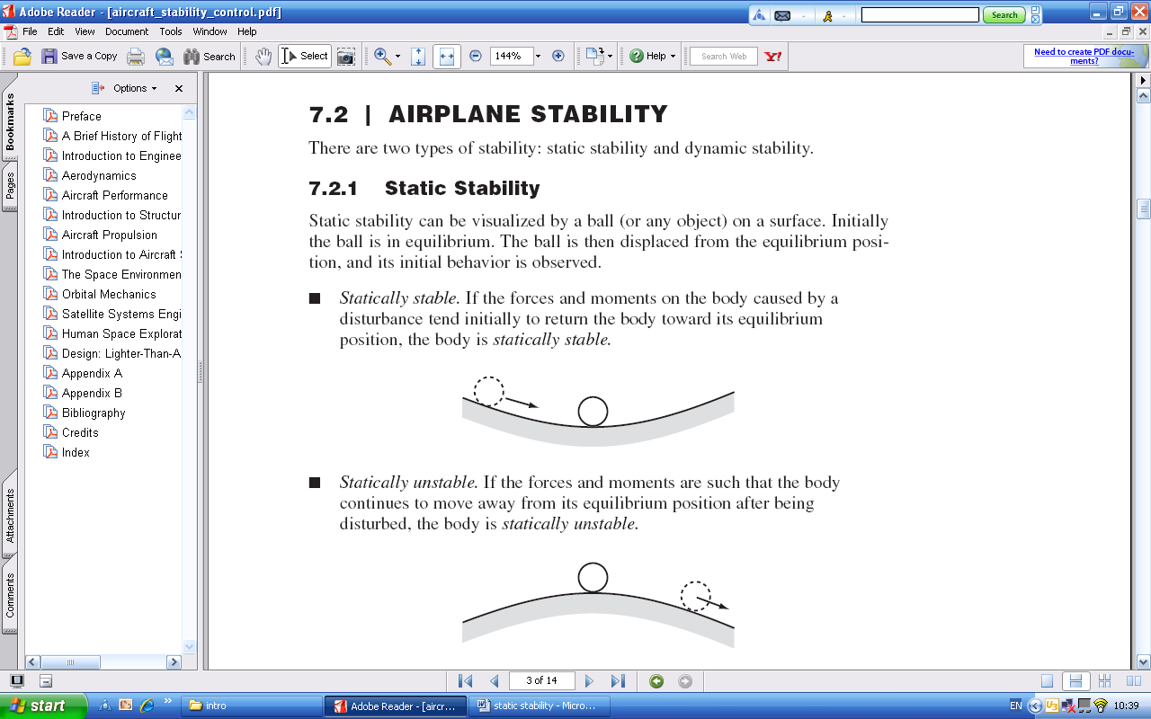

Figure1: Statically stable

Statically unstable: If the forces and moments are such that the body continues to move away from its equilibrium position after being disturbed, the body is statically unstable*.*



Figure 2: Statically neutral

Neutrally stable: If the body is disturbed but the moments remain zero, the body stays in equilibrium and is neutrally stable i.e. if the ball is displaced from its initial equilibrium point to another position the ball would remain at the new position.

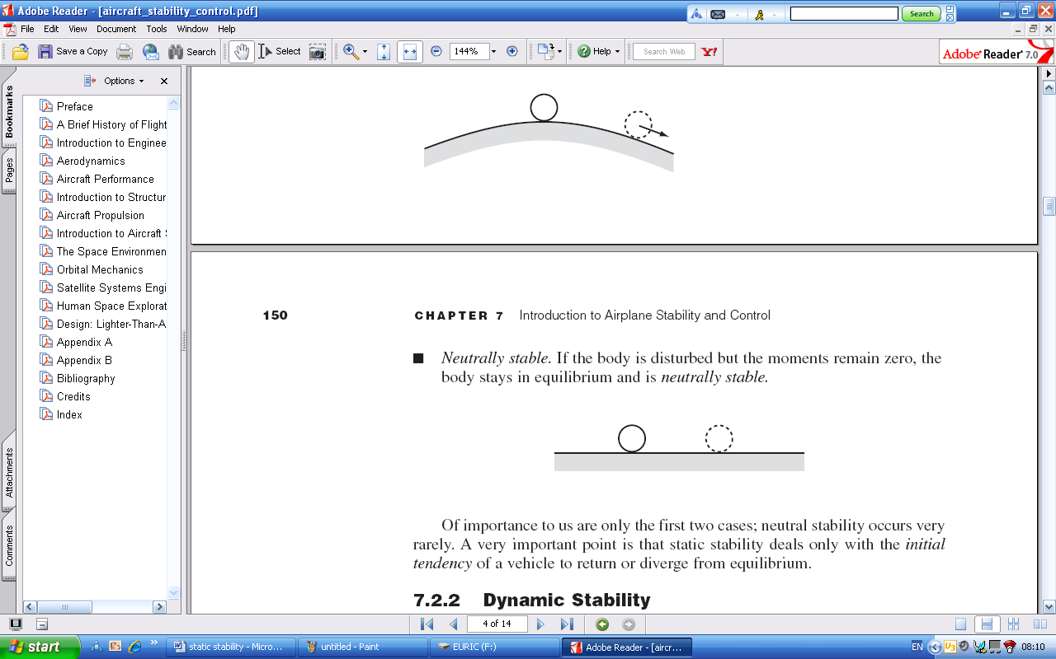

Figure 3: Neutrally stable

The important point in these examples is if the vehicle is to have a stable equilibrium, the aeroplane should be able to develop a restoring force and/ or a moment which tends to return the aeroplane back to equilibrium condition.

**STATIC FORCES AND MOMENTS ON AN AIRCRAFT**

**Resulting Force on a Wing**

There is an aerodynamic force created by the pressure and shear stress distribution over the wing surface. The resultant (net) force *R* can be resolved into two components: the lift *L* (perpendicular to the relative wind *v*) and the drag *D* (in the direction of the relative wind *v*).

**Resulting Moment on a Wing**

Consider just the pressure on the top surface of the wing. The net force due to that pressure distribution called *F*1, points downward and is acting through point 1 on the chord line. The pressure distribution on the bottom surface results in a net force *F*2, pointing upward and acting through point 2 on the chord line. The total aerodynamic force on the wing is of course a summation of F1 and F2. If F2> F1, there is lift. Since the two forces do not act through the same point, there will be a net momenton the wing. See Figure 4.

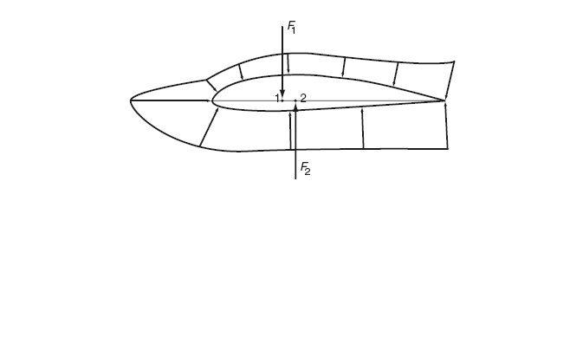

Figure 4: The origin of the moment acting on an airfoil.

The magnitude of the moment depends upon the reference point about which the moment is taken. If the moment is taken with respect to the leading edge, it is denoted by. For subsonic wings it is often customary to take the moment about the quarter-chordpoint(i.e, the point that is a distance *c*/4 away from the leading edge). This moment is denoted by. Both and  vary with the angle of attack. However, a special point exists about which the moment essentially does not vary with angle of attack. This point is called the aerodynamic center(*ac*). For that point,

= constant (independent on angle of attack)

The moment coefficient about the aerodynamic center is defined as



Where  is the dynamic pressure, *S* is *the* wing area, and *c* the chord length. The value of  is zero for symmetric airfoils and varies from -0.02 to -0.3 or so for cambered airfoils.

**Moment on an Aircraft**

Having looked at a wing only, we can now consider a complete airplane, as shown in Figure 5. In examining a whole aircraft, the pitching moment about the center of gravity (center of mass) is of interest. The moment coefficient about cg is defined analogous to the moment coefficient about the ac:



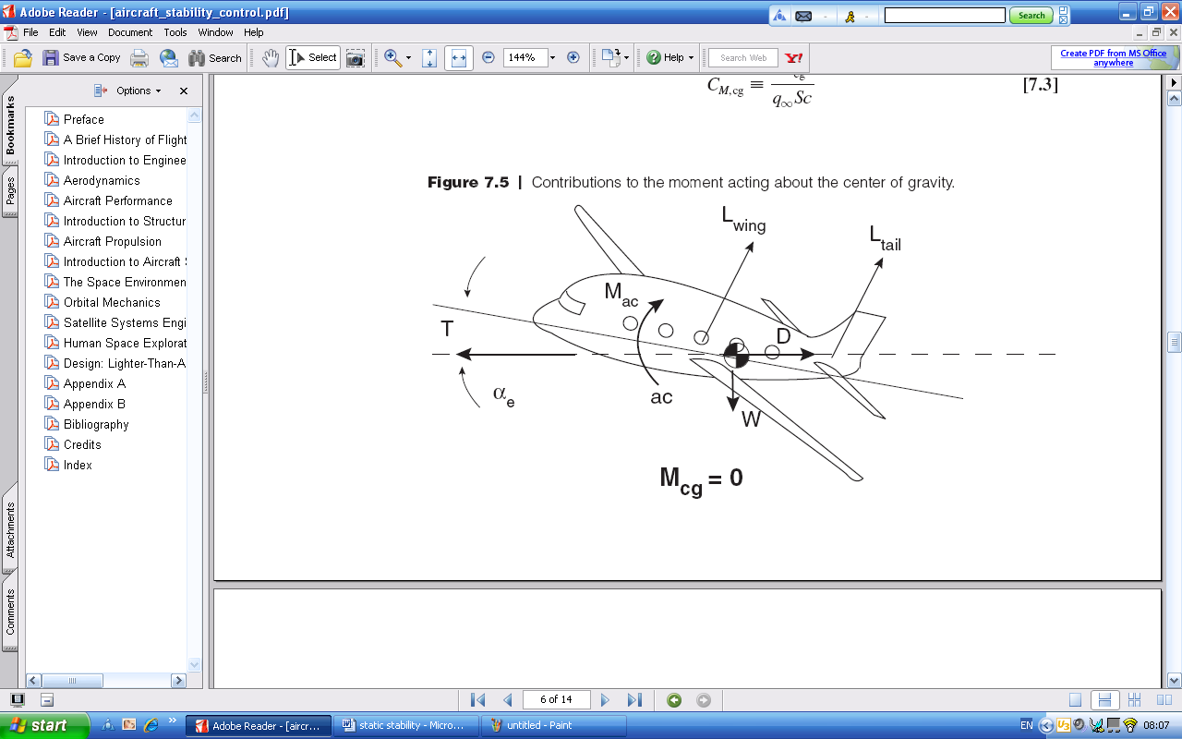Figure 5: Contributions to the moment acting about the center of gravity.

An airplane is in pitch equilibriumwhen the net moment about the center of gravity is zero.



Note that while drag plays an essential part in performance determination, its role is small for stability and control. Its value is much less than that of the lift.

**LONGITUDINAL STATIC STABILITY**

Static stability and control about all three axes is necessary in the design of conventional airplanes. Pitching stability (nose-up/ nose-down) is known as longitudinal stability. The conventional method for making an aeroplane longitudinally stable is to introduce a secondary surface, known as a tail plane/ horizontal stabilizer. Longitudinal trim involves the simultaneous adjustment of elevator angle and thrust to give the required airspeed and flight path angle for a given airframe con figuration. Equilibrium is only achievable if the aeroplane is longitudinally stable and the control actions to trim depend on the degree of longitudinal static stability. Since the longitudinal flight condition is continuously variable, it is very important that trimmed equilibrium is possible at all conditions. For this reason, considerable emphasis is given to the problems of ensuring adequate longitudinal static stability and longitudinal trim control. Consider an airplane with fixed control surfaces, Wind tunnel testing may reveal the following behavior (see Figure 6): The plot is almost linear and shows the value of theversus angle of attack. The slope of the curve is/ and is sometimes denoted with the letter “a.” (A partial derivative rather than a total derivative is used since the coefficient does not depend on alone.) The value of  at an angle of attack equal to zero is denoted by . The angle at which the moment coefficient is zero is, of course, the trim angle of attack.

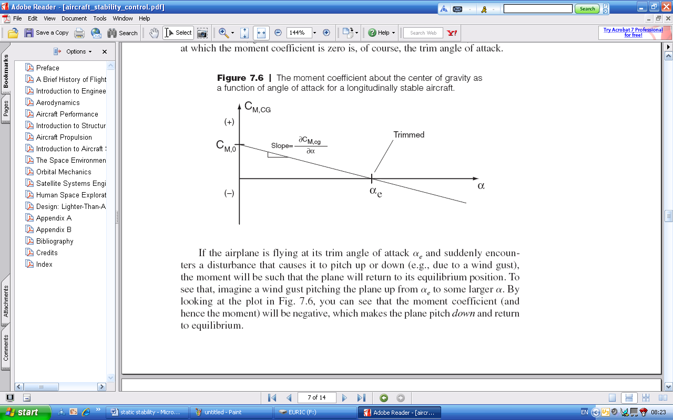

Figure 6: The moment coefficient about the center of gravity as a function of angle of attack for a longitudinally stable aircraft.

If the airplane is flying at its trim angle of attack and suddenly encounters a disturbance that causes it to pitch up or down (e.g., due to a wind gust), the moment will be such that the plane will return to its equilibrium position. To see that, imagine a wind gust pitching the plane up from to some larger . By looking at the plot in Fig. 6, you can see that the moment coefficient (and hence the moment) will be negative, which makes the plane pitch *down* and return to equilibrium. Suppose the curve  versus is as shown in Figure 7. The plane would be unstable, as you can verify yourself. Thus, we can state the necessary criteriafor longitudinal static stability and balance as

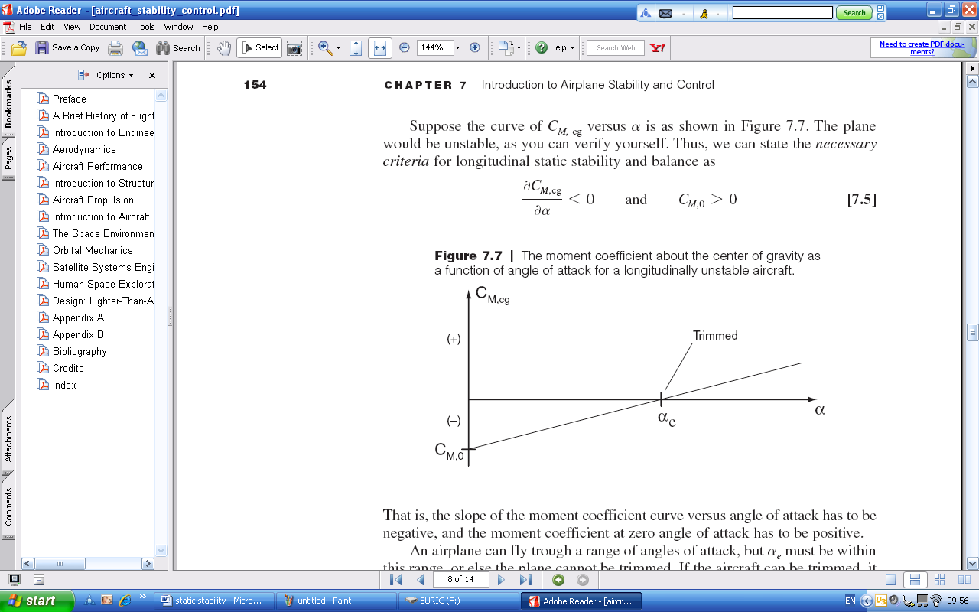 and 

Figure 7: The moment coefficient about the center of gravity as a function of angle of attack for a longitudinally unstable aircraft.

That is, the slope of the moment coefficient curve versus angle of attack has to be negative, and the moment coefficient at zero angle of attack has to be positive.

An airplane can fly trough a range of angles of attack, but must be within this range, or else the plane cannot be trimmed. If the aircraft can be trimmed, it is said to be longitudinally balanced.

If you have a wing by itself, it will usually have a negativeand thus negative  (this is characteristic of all airfoils with positive camber). Therefore a wing by itself is unbalanced. To correct the situation, a horizontal stabilizer is mounted behind the wing. If the wing is inclined downward to produce a negative lift, then a clockwise moment about the cg will be created. If this clockwise moment is large enough, it will overcome the negative  for the wing-tail combination, making the aircraft as a whole longitudinally balanced.

**Conditions for longitudinal static stability**

* The center of gravity is further forward in the stable aeroplane than unstable aeroplane.
* In a stable aeroplane, the wing is set at a higher incidence angle than the tail. The difference between the incidence angles at which the wing and tail are set is called the longitudinal dihedral.

**Controls fixed stability:** The condition described as controls fixed is taken to mean the condition when the elevator and elevator tab are held at constant settings corresponding to the prevailing trim conditions.

**Controls free stability:** The condition described as controls free is taken to mean the conditionwhen the elevator is free to float at an angle corresponding to the prevailing trim condition. In practice this means that the pilot can fly the aeroplane with his hands off the controls whilst the aeroplane remains in its trimmed flight condition.

**Lateral static stability**

Lateral static stability is concerned with the ability of the aeroplane to maintain wings level equilibrium in roll. Wing dihedral is the most visible parameter which confers lateral static stability on an aeroplane although there are many other contributions, some of which are destabilizing. Most light aircraft display approximately neutral lateral static stability, in other words when rolled into a given bank and released the aircraft remains more or less at that angle of bank. If the aircraft rolled back to zero bank by itself we would say it had positive static lateral stability. If it rolled further, into a steeper bank we would say it was displaying negative static lateral stability.

Most light aircraft if left with no pilot input will eventually roll into a steeper turn, usually entering a spiral dive. This means that most aircraft exhibit negative dynamic lateral stability. Despite this they can be flown quite well, except they require considerable attention when flying in certain conditions.

As indicated above lateral stability and directional stability are closely linked. If an aircraft has a lot of directional stability (most do) it tends to become unstable laterally. This is because the bank angle starts the aircraft turning, which speeds up the wing on the outside of the turn (high wing). The faster wing produces more lift, which rolls the aircraft into a steeper bank. All aircraft will exhibit negative lateral static stability, as describe above, unless the designer adds some combination of the design features listed below to combat the effect described above.

[**Dihedral**](http://selair.selkirk.bc.ca/aerodynamics1/Stability/dihedral.htm)

[Dihedral](http://selair.selkirk.bc.ca/aerodynamics1/Stability/dihedral.htm) is the most common design feature used to increase the lateral stability. In order to understand dihedral you must realize that the side force created by a bank angle will pull the aircraft sideways through the air. In other words it will cause the aircraft to slip.

As mentioned above the aircraft will slip once it enters a banked attitude. However, the directional stability will quickly turn the aircraft into this new relative wind. As a result, the slip will quickly disappear and the dihedral effect will be eliminated

**High Wing Effect**

Aircraft with high wings will have more lateral stability than aircraft which have low wings. This is often referred to as the pendulum effect, although that is incorrect. Since high and low wing airplanes can be visualized in this way the term "high wing effect" and "pendulum effect" have often been used interchangeable. It is a good way to remember that high wing airplanes are stable and low wing airplanes are not. The real reason a high wing airplane is stable is that ifit slips toward the low wing, the angle of attack on the low wing increases, due to air being deflected by the fuselage. While this has the same effect as a pendulum the mechanism differs since it only works if there is a slip. The important thing to note is that high wing effect will only work if the airplane slips, which is the same as the dihedral effect discussed above.

**Swept wings**

Swept wings are one of the most effective ways of increasing lateral stability. However, they are usually only used on high speed jet aircraft. Therefore, this effect is reserved only for those lucky enough to fly a jet. Just as with the dihedral effect, the swept wing affects lateral stability because the aircraft tends to slip initially once banked.

**Static Directional Stability**

Static directional stability is a measure of the aircraft's resistance to slipping. The greater the static directional stability the quicker the aircraft will turn into a relative wind which is not aligned with the longitudinal axis. The main contributor to the static directional stability is the fin. Both the size and arm of the fin determine the directional stability of the aircraft**.** The further the vertical fin is behind the center of gravity the more static directional stability the aircraft will have. (This is often called the weather veining effect, because it works the same way as a weather vein.) As mentioned previously all rotational motions of the aircraft occur around the center of gravity**.** Directional stability refers to motions around the normal axis.

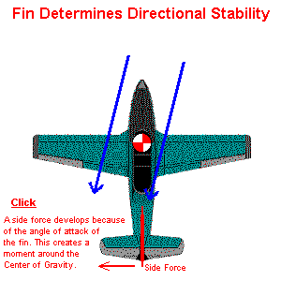

**LATERAL STATIC STABILITY**

An airplane possesses lateral static stability if, when it is disturbed from wing-level attitude, a restoring moment is developed, the restoring rolling moment. The restoring moment can be shown to be a function of the side slip angle β as illustrated in the figure below.

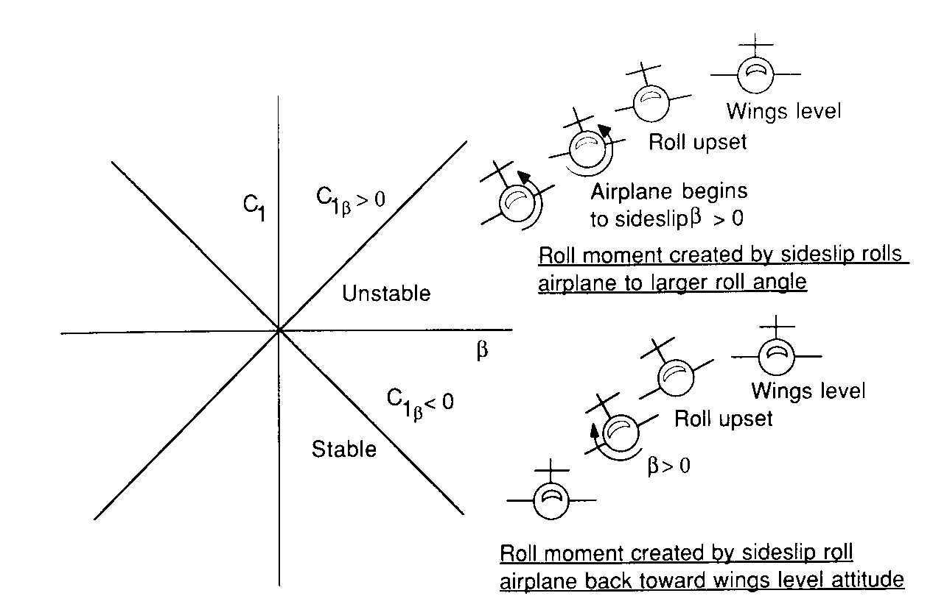

The requirement for stability is that $C_{Iβ}<0$ the roll moment on an airplane when it starts to sideslip depends upon wing dihedral, wing sweep, position of wing on fuselage and the vertical tail. The major contributor to *Clβ* is the wing dihedral angle ᴦ. The dihedral angle is defined as the spanwise inclination of the wing with respect to the horizontal. If the wing tip is higher than the root section, then the dihedral angle is positive; if the wing tip angle is lower than the root section, then the dihedral angle is negative. A negative dihedral angle is commonly called anhedral.

When an airplane is disturbed from a wing-level attitude, it will begin to sideslip. Once the airplane starts to sideslip a component of the relative wind is directed toward the side of the airplane. The leading wing experiences an increased angle of attack and consequently an increase in lift. The trailing wing experiences the opposite effect. The net result is a rolllng moment that tries to bring the wing back to a wings-level attitude. This restoring moment is often refferd to as the “dihedral effect”. The wing sweep also contributes to the dihedral effect. In the case of a sweptback wing, the windward wing has an effective decrease in sweep angle while the trailing wing experiences and effective increase in sweep angle. For a given angle of attack, a decrease in sweepback angle will result in a higher lift coefficient. Therefore, the windward wing(less effective sweep) will experience moore lift than the trailing wing. It can be concluded that sweepback adds to the dihedral effect. On the other hand, sweepforward will decrease the effective dihedral effect. The fuselage contribution to dihedral effect is illustrated in the figure below.



* **Stability Concepts**   
    
  The aircraft's response to momentary disturbance is associated with its   
  inherent degree of stability built in by the designer, in each of the three axes,   
  and occurring without any reaction from the pilot.   
    
  There is another condition affecting flight, which is the aircraft's state of trim   
  or equilibrium (where the net sum of all forces equals zero).   
  Some aircraft can be trimmed by the pilot to fly 'hands off' for straight and   
  level flight, for climb or for descent.   
    
  Free flight models generally have to rely on the state of trim built in by the  
  designer and adjusted by the rigger, while the remote controlled models have  
  some form of trim devices which are adjustable during the flight.   
    
  An aircraft's stability is expressed in relation to each axis:   
  **lateral stability** (stability in roll), **directional stability** (stability in yaw)  
  and **longitudinal stability** (stability in pitch).  
  Lateral and directional stabilities are inter-dependent.   
    
  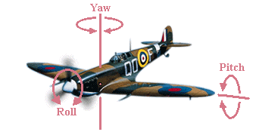  
    
  Stability may be defined as follows:  
  - Positive stability: tends to return to original condition after a disturbance.  
  - Negative stability: tends to increase the disturbance.  
  - Neutral stability: remains at the new condition.  
    
  - **Static stability**: refers to the aircraft's **initial** response to a disturbance.  
  A statically unstable aircraft will uniformly depart from a condition of equilibrium.  
    
  - **Dynamic stability**: refers to the aircraft's ability to damp out oscillations, which  
    depends on how fast or how slow it responds to a disturbance.  
  A dynamically unstable aircraft will (after a disturbance) start oscillating with  
  increasing amplitude.  
  A dynamically neutrally stable aircraft will continue oscillating after a disturbance  
  but the amplitude of the oscillations will not change.   
    
  So, a statically stable aircraft may be dynamically unstable.  
  Dynamic instability may be prevented by an even distribution of weight inside the  
  fuselage, avoiding too much weight concentration at the extremities or at the CG.  
  Also, control surfaces' max throws may affect the flight stability, since a too much  
  control throw may cause instability, e.g. Pilot Induced Oscillations (PIO).   
    
  Static stability is proportional to the stabiliser area and the tail moment.   
  You get double static stability if you double the tail area or double the tail moment.  
  Dynamic stability is also proportional to the stabiliser area but increases with the  
  square of the tail moment, which means that you get four times the dynamic stability  
  if you double the tail arm length.   
    
  However, making the tail arm longer or encreasing the stabiliser area will move  
  the mass of the aircraft towards the rear, which may also mean the need to make  
  the nose longer in order to minimize the weight required to balance the aircraft...   
    
  A totally stable aircraft will return, more or less immediately, to its trimmed state  
  without pilot intervention.  
  However, such an aircraft is rare and not much desirable. We usually want an   
  aircraft just to be reasonably stable so it is easy to fly.  
  If it is too stable, it tends to be sluggish in manoeuvring, exhibiting too slow   
  response on the controls.   
    
  Too much instability is also an undesirable characteristic, except where an  
  extremely manoeuvrable aircraft is needed and the instability can be continually  
  corrected by on-board 'fly-by-wire' computers rather than the pilot, such as a  
  supersonic air superiority fighter.   
    
  **Lateral stability** is achieved through dihedral, sweepback, keel effect and  
  proper distribution of weight.  
  The dihedral angle is the angle that each wing makes with the horizontal (see  
  Wing Geometry).  
  If a disturbance causes one wing to drop, the lower wing will receive more lift  
  and the aircraft will roll back into the horizontal level.   
    
  A sweptback wing is one in which the leading edge slopes backward.   
  When a disturbance causes an aircraft with sweepback to slip or drop a wing,  
  the low wing presents its leading edge at an angle more perpendicular to the  
  relative airflow. As a result, the low wing acquires more lift and rises, restoring  
  the aircraft to its original flight attitude.   
    
  The keel effect occurs with high wing aircraft. These are laterally stable simply  
  because the wings are attached in a high position on the fuselage, making the  
  fuselage behave like a keel.   
  When the aircraft is disturbed and one wing dips, the fuselage weight acts like  
  a pendulum returning the aircraft to the horizontal level.   
    
  The tail fin determines the **directional stability**.  
  If a gust of wind strikes the aircraft from the right it will be in a slip and the fin  
  will get an angle of attack causing the aircraft to yaw until the slip is eliminated.   
    
    
  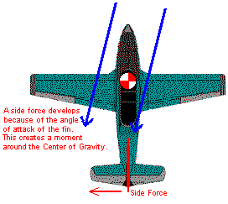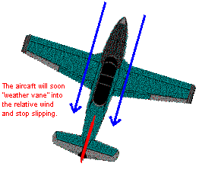  
    
  **Longitudinal stability** depends on the location of the centre of gravity, the  
  stabiliser area and how far the stabiliser is placed from the main wing.  
  Most aircraft would be completely unstable without the horizontal stabiliser.   
    
  Non-symmetrical cambered airfoils have a higher lift coefficient, but they also   
  have a negative pitching moment (Cm) tending to pitch nose-down, and thus   
  being statically unstable, which requires the counter moment produced by the   
  horizontal stabiliser to get adequate longitudinal stability.  
  The stabiliser provides the same function in longitudinal stability as the fin does  
  in directional stability.   
    
  Symmetrical (zero camber) airfoils have normally a zero pitching moment,  
  resulting in neutral stability, which means the aircraft goes wherever you point it.  
  Reflexed airfoils (with trailing edge bent up) have a positive pitching moment  
  making them naturally stable, they are often used with flying wings (without the  
  horizontal stabiliser).   
    
  It is of crucial importance that the aircraft's **Centre of Gravity (CG)** is located   
  at the right point, so that a stable and controllable flight can be achieved.  
  In order to achieve a good longitudinal stability, the CG should be ahead of the   
  **Neutral Point (NP)**, which is the Aerodynamic Centre of the whole aircraft.   
  NP is the position through which all the net lift increments act for a change in   
  angle of attack.  
  The major contributors are the main wing, stabiliser surfaces and fuselage.   
    
  The bigger the stabiliser area in relationship to the wing area and the longer   
  the tail moment arm relative to the wing chord, the farther aft the NP will be and   
  the farther aft the CG may be, provided it's kept ahead of the NP for stability.   
    
  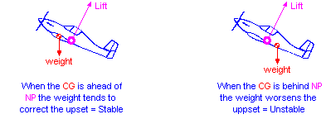  
    
  The angle of the fuselage to the direction of flight affects its drag, but has little  
  effect on the pitch trim unless both the projected area of the fuselage and its  
  angle to the direction of flight are quite large.   
    
  A **tail-heavy** aircraft will be more unstable and susceptible to stall at low speed  
  e. g. during the landing approach.  
  A **nose-heavy** aircraft will be more difficult to takeoff from the ground and to  
  gain altitude and will tend to drop its nose when the throttle is reduced. It also  
  requires higher speed in order to land safely.   
    
  The angle between the wing chord line and the stabiliser chord line is called   
  the **Longitudinal Dihedral (LD)** or decalage.  
  For a given centre of gravity, there is a LD angle that results in a certain   
  trimmed flight speed and pitch attitude.   
  If the LD angle is increased the plane will take on a more nose up pitch attitude,  
  whereas with a decreased LD angle the plane will take on a more nose down  
  pitch attitude.   
  There is also the **Angle of Incidence**, which is the angle of a flying surface  
  related to a common reference line drawn by the designer along the fuselage.  
  The designer might want this reference line to be level when the plane is flying   
  at level flight or when the fuselage is in it's lowest drag position.  
  The purpose of the reference line is to make it easier to set up the relationships   
  among the thrust, the wing and the stabiliser incidence angles.  
  Thus, the Longitudinal Dihedral and the Angle of Incidence are interdependent.   
    
  Longitudinal stability is also improved if the stabiliser is situated so that it lies  
  outside the influence of the main wing downwash.  
  Stabilisers are therefore often staggered and mounted at a different height in   
  order to improve their stabilising effectiveness.   
    
  It has been found both experimentally and theoretically that, if the aerodynamic   
  force is applied at a location 1/4 from the leading edge of a rectangular wing   
  at subsonic speed, the magnitude of the aerodynamic moment remains nearly   
  constant even when the angle of attack changes.  
  This location is called the wing's **Aerodynamic Centre AC**.   
  (At supersonic speed, the aerodynamic centre is near 1/2 of the chord).   
    
  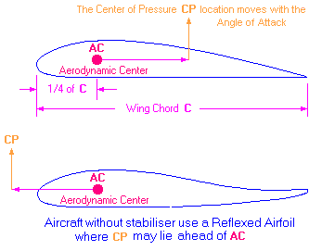  
    
  In order to obtain a good Longitudinal Stability the **Centre of Gravity CG**  
  should be close to the main wings' **Aerodynamic Centre AC**.  
  For wings with other than rectangular form (such as triangular, trapezoidal,   
  compound, etc.) we have to find the **Mean Aerodynamic Chord - MAC**,   
  which is the average for the whole wing.  
  The MAC calculation requires rather complicated mathematics, so a simpler  
  method called 'Geometric Mean Chord' GMC or 'Standard Mean Chord' SMC   
  may be used as shown on the drawings below.  
  MAC is only slightly bigger than GMC except for sharply tapered wings.  
  Taper ratio = tip chord/root chord.   
    
  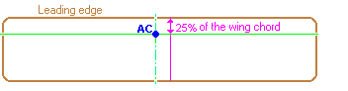  
  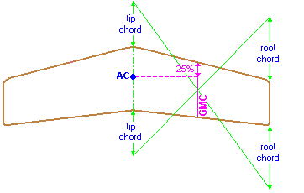  
  To calculate MAC of a tapered wing, the following simplified equation  
  may be used:  
  MAC = root chord \* 2/3 \* ((1+T+T2)/(1+T))  
  Where T is the wing's taper ratio.  
    
  The MAC distance from the center line may be calculated as follows:  
  distance = half span \* (1+2\*T)/(3+3\*T)  
    
  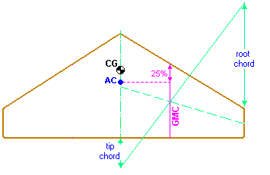  
  For a delta wing the **CG** should be located 10% ahead of the geometrically  
  calculated **AC** point as shown above.  
  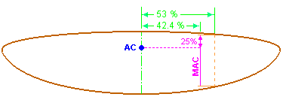  
  The MAC of an elliptical wing is 85% of the root chord and is located at 42.4% of  
  the half wingspan from the root chord.  
  Elliptical wing's area = pi \* wingspan \* root chord/4   
    
  The **AC** location for biplanes with positive stagger (top wing ahead of the bottom  
  wing), is found according to the drawing below.  
  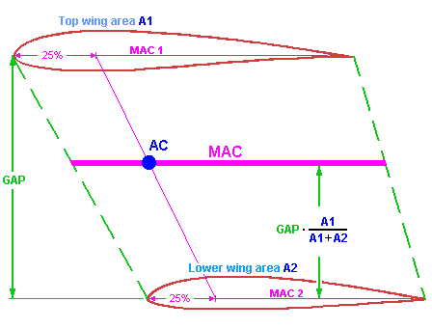  
  For conventional designs (with main wing and horizontal stab) the **CG** location   
  range is usually between 28% and 33% from the leading edge of the main  
  wing's MAC, which means between about 5% and 15% ahead of the aircraft's   
  Neutral Point **NP**.  
  This is called the **Static Margin**, which is expressed as a percentage of MAC.  
  When the static margin is zero (CG coincident with NP) the aircraft is considered  
  "neutrally stable".  
  However, for conventional designs the static margin should be between 5% and   
  15% of the MAC ahead of the NP.   
    
  The CG location as described above is pretty close to the wing's Aerodynamic  
  Center AC because the lift due to the horizontal stab has only a slightly effect on  
  the conventional R/C models.   
    
  However, those figures may vary with other designs, as the NP location depends   
  on the size of the main wing vs. the stab size and the distance between the main   
  wing's AC and the stab's AC.  
  The simplest way of locating the aircraft's NP is by using the areas of the two   
  horizontal lifting surfaces (main wing and stab) and locate the NP proportionately  
  along the distance between the main wing's AC point and the stab's AC point.  
  For example, the NP distance to the main wing's AC point would be:  
  D = L **·** (stab area) / (main wing area + stab area) as shown on the picture below:  
  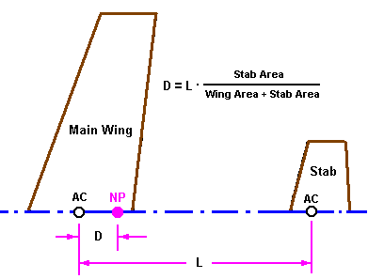  
    
  There are other factors, however, that make the simple formula above inaccurate.  
  In case the two wings have different aspect ratios (different dCL/d-alpha) the NP  
  will be closer to the one that has higher aspect ratio.  
  Also, since the stab operates in disturbed air, the NP will be more forward than  
  the simple formula predicts.   
    
  The figure below shows a somewhat more complex formula to locate the NP but  
  would give a more accurate result using the so called Tail Volume Ratio, **Vbar**.  
  This formula gives the NP position as a percentage (%) of the wing's MAC aft of   
  the wing's AC point.   
    
  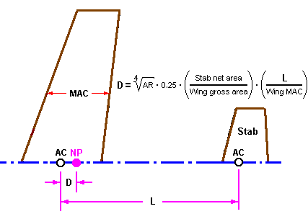  
    
  For those who are not so keen on formulas and calculations there is the  
  [Aircraft Center of Gravity Calculator](http://adamone.rchomepage.com/cg_calc.htm" \t "_blank), which automatically calculates the CG   
  location as well as other usuful parameters based on the formula above.   
    
  For Canards check the link below:  
  [Canard Center of Gravity Calculator](http://adamone.rchomepage.com/cg_canard.htm)   
    
  For further equations on how to find the proper CG location with different wing  
  shapes and design configurations including Canards, check [here.](http://www.palosrc.com/instructors/putte.pdf)

QUESTIONS

1(a) Distinguish between the terms ‘static stability’ and ‘dynamic stability’. 2marks

Sketching where appropriate, curves showing the kind of motion that might exist; discuss which of the following are possible:

i) An aircraft that is statically stable but dynamically unstable.

ii) An aircraft that is statically unstable but dynamically unstable

iii) An aircraft that is both statically and dynamically stable. 6marks

(b) Starting with the equations for static stability analysis provided, show that the neutral point may be determined:



2(a) Explain the following terms as applied in aeronautics:

i. Controls fixed

ii Controls free.

3(a) Describe the mechanism by which wing dihedral contributes to the lateral static stability of an aircraft. 3marks

(b) Explain the effect of:

i) High wing position

ii) Wing sweep-back

have on lateral static stability? 4marks

4(a) Explain briefly the following terms as applied in aeronautics:

(i) Static stability

(ii) Controls free

(iii) Controls fixed

(iv) Stick fixed

(v) Stick free

(vi) Neutral point

(vii) Static margin

(viii) Centre of gravity

(ix) Angle of attack

(x) Centre of pressure

How can designer Ensure Longitudinal Static stability?

What is the price paid for a large static stability margin?

The type of controls in the aeroplane are:

1. Cable and pulley
2. Push-rod
3. Hydraulic
4. Fly-By-Wire